Little SPARK: Simple Play Adaptations to Reference for Kids

Rainbow Liquid Sensory Viewers
Description: | Image:
Set of 5 durable plastic viewers in 5 colors; each viewer measures 5 3/4" tall.  Purchasing Information  Demo Video | 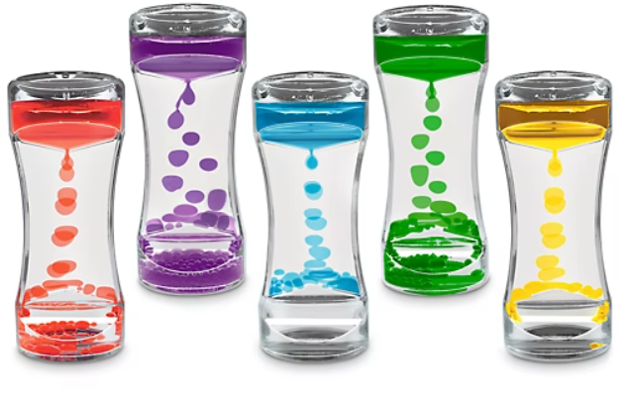

Who Might Benefit?
Those who are learning self-regulation, need quiet, self-directed activities to regroup, or benefit from touching/fidgeting to focus.
Why Use?
Quiet sensory exploration and self-calming tool that can help a child’s focus and regulation.
Instructions for Use: | Adaptation Ideas:
Environmental Considerations  - Use individually in quiet areas  Positioning & Alternate Positioning  - Explore in just about any position where they can be reached and viewed.  Basic Play/Use Extended Play/Use  - Shake, tip or swirl the bottles and watch the contents move and settle. Play color identification activities or explore/use in conjunction with a light box.  Play/Use with Others  - Take turns color matching with picture or color words to each bottle. | Build It Up  - Use Dycem, or shelf liner to provide gripping surface.  Stabilize It  - Shallow box or cylindrical holder to help hold/set up bottle upright.  Simplify It  - Introduce one bottle at a time.  Contain It  - Store in open container alone or sensory tub with other items.  Add Sensory Cues  - Use with light box or with quiet music.  Communication Supports  - Visual supports like communication cards and social narratives can help a child communicate their feelings.  Alternative Uses  - Use as timers or visual transitions (“When the bubbles settle it’s time to…”).  DIY Alternatives  - Make your own sensory bottle

Words to Encourage Play/Use
Turn  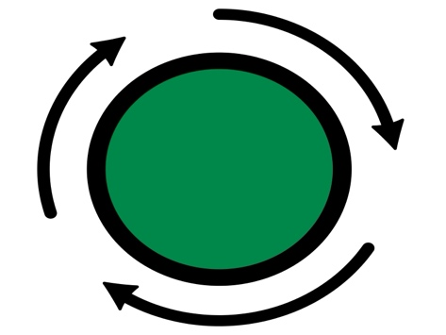 | Look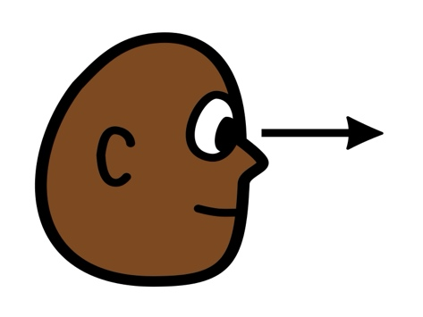 | Calm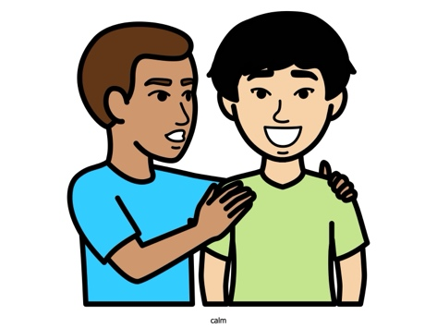
Wait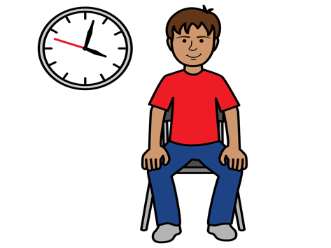 | Bubbles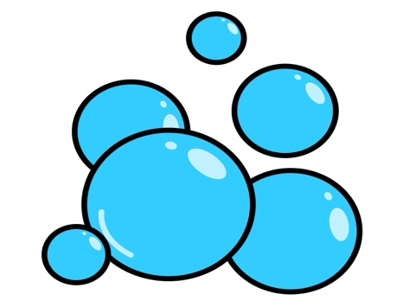 | Color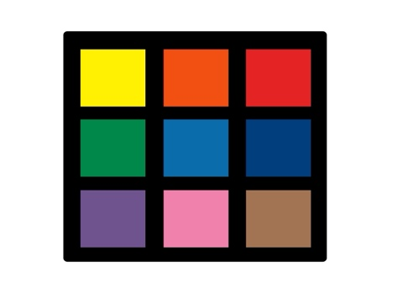
Help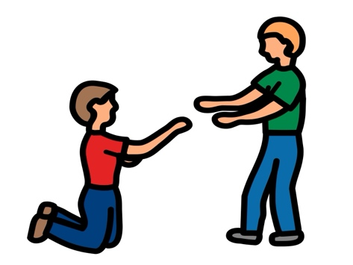 | Touch | Shake  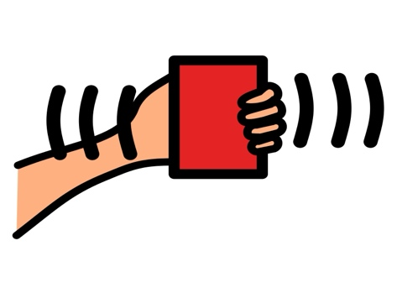
*”Adaptations” adapted from: Haugen’s Modes for Adapting Toys based on materials from the "Let's Play" Project at the University of Buffalo
PCS is a trademark of Tobii Dynavox, LLC. All rights reserved. Used with permission.

